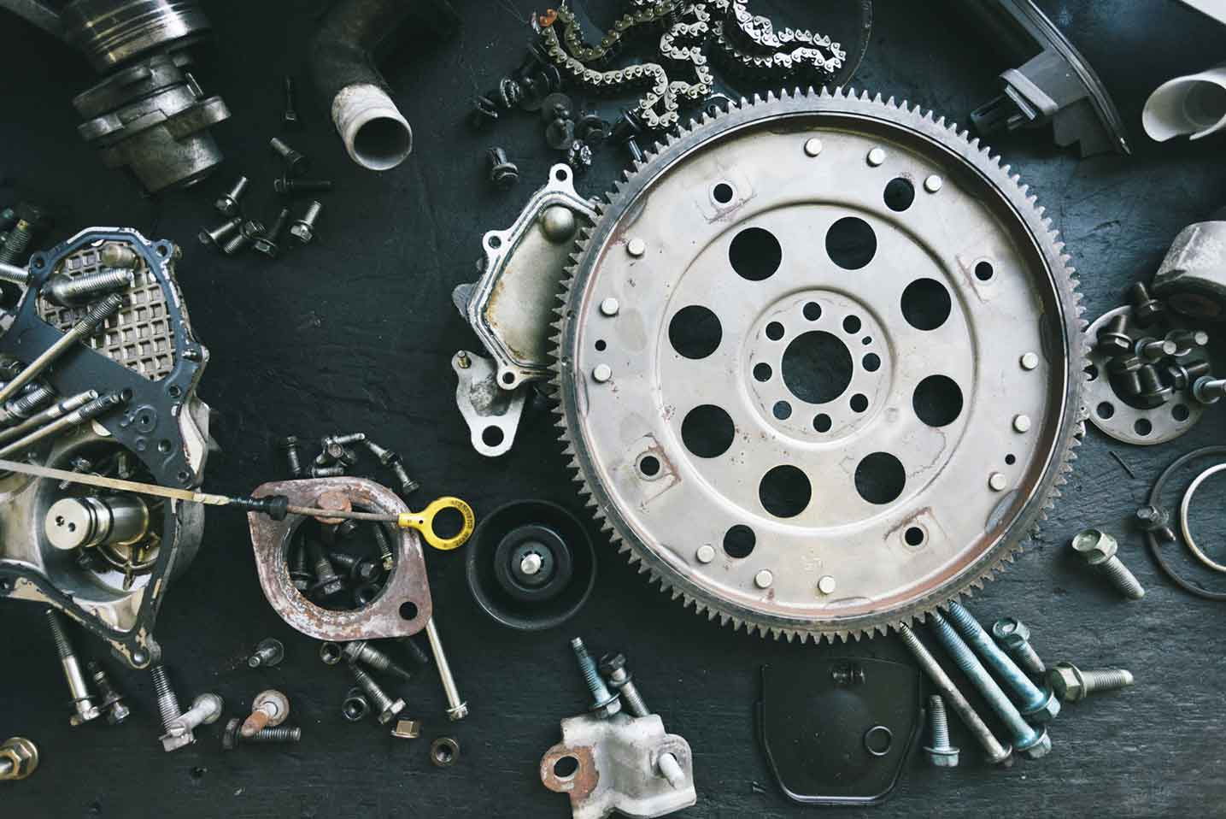



  - Process Definition
Document

Table Reservation Management System

-

  - Team Titan
  - -Palaniyappan
  - -Alok Ranjan Patel

Table of Contents
I. INTRODUCTION 5
1.1 Purpose 5
1.2 Objectives 5
1.3 Process Overview 6
1.4 Applications Used 7
III. AS IS Process description 10
2.1 AS IS Process Map 8
2.1.1 High Level Process Map 8
III. TO BE Process description 10
3.1. Exceptions Handling 11
IV. Other 13
4.1. Additional sources of process documentation 13

INTRODUCTION

Purpose
The Process Definition Document outlines the business process chosen for automation. The document describes the sequence of steps performed as part of the business process, the conditions and rules of the process prior to automation (AS IS) as well as the new sequence of steps that the process will follow as a result of preparation for automation (TO BE).
The PDD is a communication document between:
- The RPA Business Analyst and the SME/Process Owner. The goal is to ensure that the RPA Business Analyst has the correct understanding of the process and has represented it accurately.
- The RPA Business Analyst and the Development team (represented by the Solution Architect and RPA Development Lead). The goal is to ensure that the process is documented appropriately and to a sufficient level of detail so that the Solution Architect can then create the solution based on the PDD content.

Objectives
Many forms of automation exist to provide intelligent insights to guide the human workforce towards an optimal action. There are so many sources of data that can be forged to create intelligent automation that improves labor management, inventory management, food quality, food waste, sustainability and customer experience. In many cases, we can address multiple pain points with one grand plan.
Considering hospitality a major part of management in restaurants, the initial stage of Booking and reserving the table has a great potential of being automated. This process main objective is to take the data from user and validate simultaneously and make their diet a dramatic experience even while booking their table.

Minimum Pre-requisites for the Automation
- UiPath Cloud account - UiPath Apps
- Modern folder creation for accessing UiPath Data Services
- Filled in Process Definition Document
- Test Data to support development
- User access and user accounts creations (licenses, permissions, restrictions to create accounts for robots)
- Credentials (user ID and password) required to logon to machines and applications

Applications Used
- UiPath Apps
- UiPath Data Service
- UiPath Studio Pro
- UiPath Robot
- UiPath Orchestrator

AS IS Process

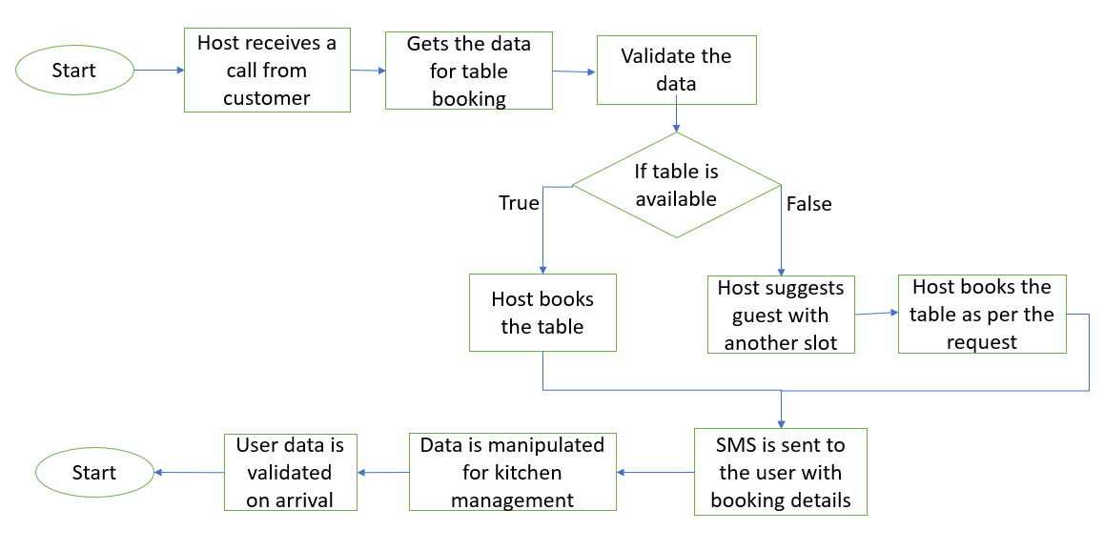

Process Overview
Section contains general information about the process before automation.  Item | Description/Answer
Process Full Name | Table Reservation Management System for Restaurants
Process Area | Restaurants
Department | Hospitality
Process schedule and frequency | On Daily Basis
Number of times the process is ran by selected frequency | Based on guests visit
Process execution time | 10 mins per request
Process Restrictions | The application might be used by any user at any time. So the bot should be able to handle multiple requests at a time, 24*7
Peak Period (s) | During Festive seasons and on weekends.
Peak Volume Approximate increase | 50 booking a day
Number of persons performing the process | Multiple
Expected Volume increase during next periods | 30-40%
Input data description | User calls and provide the data to a person at restaurants
Output Data description | User will be receiving a SMS with booking details

TO BE Process description

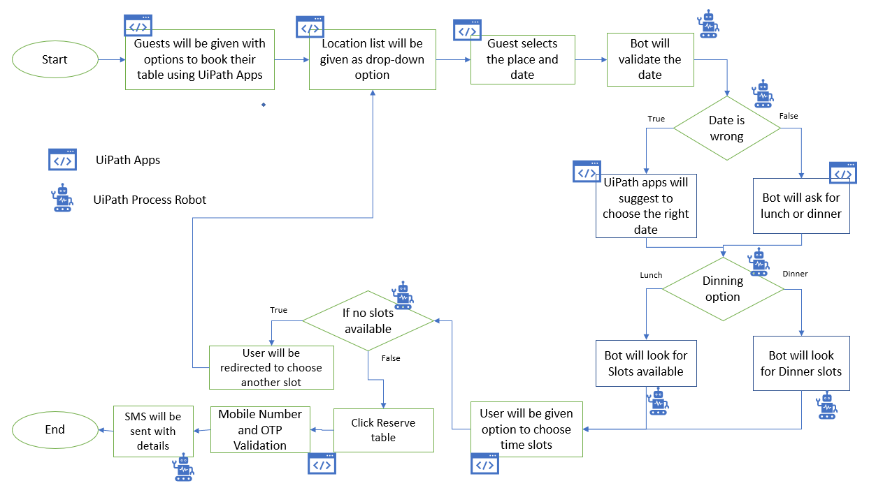

Exceptions Handling
Details regarding how the robot should handle the exceptions.
Exception Name | Step | Parameters | Action to be taken
When user enter wrong date value for table booking | Enter date of booking | MM-dd-yyyy format | UiPath Apps should show a message prompt where in the user needs to re-enter the date value
When user tries to book table for lunch and cancels it | Checking in Lunch box check box | Yes or No | Both the check box must be kept unchecked so that the user can choose to their need again
When table is not available as per user request | Choosing time slots as required | Hh:mm tt format | UiPath apps should reload, enabling user to reenter with other options
Phone number not mentioned correctly | Enter mobile number to validate the booking details | +91….. format | UiPath Apps should show a message prompt stating that user needs to enter data to proceed further
OTP not sent to user via SMS | OTP sent to user for validation | Xxxxxx format | UiPath bot thrown exception must be handled

Other

Additional sources of process documentation
Additional Process Documentation
Video Recording of the process (Optional) | Acme-System1-Process-WI5-Manual-Walkthrough | Insert any relevant comments
Business Rules Library (Optional) | Insert link to Business rules library | Insert any relevant comments
Other documentation (Optional) | Insert link to any other relevant process documentation (L4, L5 process description, fields mapping files etc.) | Insert any relevant comments
Standard Operating Procedure(s) (Optional) |  | Insert any relevant comments
High Level Process Map (Optional) |  | Insert any relevant comments
Detailed level process map (Optional) |  | Insert any relevant comments
Work Instructions (Optional) |  | Insert any relevant comments
Input Files (Optional) |  | Insert any relevant comments
Output Files (Optional) |  | Insert any relevant comments
*Add more rows to the table to reflect the complete documentation provided to support the RPA process.

